**4-BIT MAGNITUDE COMPARATOR:**

module MagCom(a,b,x,y,z);

input [3:0]a,b;

output x,y,z;

wire w1,w2,w3,w4,w5,w6,w7,w8,w9,w10,w11,w12;

and(w1,a[3],~b[3]);

and(w2,a[2],~b[2],w5);

and(w3,a[1],~b[1],w6);

and(w4,a[0],~b[0],w5,w6,w7);

or(x,w1,w2,w3,w4);

xnor(w5,a[3],b[3]);

xnor(w6,a[2],b[2]);

xnor(w7,a[1],b[1]);

xnor(w8,a[0],b[0]);

and(y,w5,w6,w7,w8);

and(w9,~a[3],b[3]);

and(w10,~a[2],b[2],w5);

and(w11,~a[1],b[1],w5,w6);

and(w12,~a[0],b[0],w5,w6,w7);

or(z,w9,w10,w11,w12);

endmodule

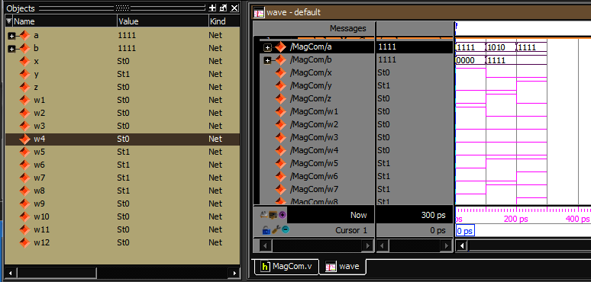

|  |  |  |  |
| --- | --- | --- | --- |
| **MagCom Project Status (07/29/2025 - 04:01:33)** | | | |
| **Project File:** | ex1.xise | **Parser Errors:** | No Errors |
| **Module Name:** | MagCom | **Implementation State:** | Programming File Generated |
| **Target Device:** | xc3s400-4ft256 | * **Errors:** | No Errors |
| **Product Version:** | ISE 14.6 | * **Warnings:** | No Warnings |
| **Design Goal:** | Balanced | * **Routing Results:** | [All Signals Completely Routed](D://ms/ex1/MagCom.unroutes) |
| **Design Strategy:** | [Xilinx Default (unlocked)](Xilinx%20Default%20(unlocked)?&DataKey=Strategy) | * **Timing Constraints:** |  |
| **Environment:** | [System Settings](D://ms/ex1/MagCom_envsettings.html) | * **Final Timing Score:** | 0  [(Timing Report)](D://ms/ex1/MagCom.twx?&DataKey=XmlTimingReport) |

|  |  |  |  |  |  |
| --- | --- | --- | --- | --- | --- |
| **Device Utilization Summary** | | | | | [**[-]**](?&ExpandedTable=DeviceUtilizationSummary) |
| **Logic Utilization** | **Used** | **Available** | **Utilization** | **Note(s)** | |
| Number of 4 input LUTs | 10 | 7,168 | 1% |  | |
| Number of occupied Slices | 5 | 3,584 | 1% |  | |
| Number of Slices containing only related logic | 5 | 5 | 100% |  | |
| Number of Slices containing unrelated logic | 0 | 5 | 0% |  | |
| Total Number of 4 input LUTs | 10 | 7,168 | 1% |  | |
| Number of bonded [IOBs](D://ms/ex1/MagCom_map.xrpt?&DataKey=IOBProperties) | 11 | 173 | 6% |  | |
| Average Fanout of Non-Clock Nets | 2.41 |  |  |  | |

|  |  |  |  |  |
| --- | --- | --- | --- | --- |
| **Performance Summary** | | | | [**[-]**](?&ExpandedTable=PerformanceSummary) |
| **Final Timing Score:** | 0 (Setup: 0, Hold: 0) | **Pinout Data:** | [Pinout Report](D://ms/ex1/MagCom_par.xrpt?&DataKey=PinoutData) | |
| **Routing Results:** | [All Signals Completely Routed](D://ms/ex1/MagCom.unroutes) | **Clock Data:** | [Clock Report](D://ms/ex1/MagCom_par.xrpt?&DataKey=ClocksData) | |
| **Timing Constraints:** |  |  |  | |

|  |  |  |  |  |  |  |
| --- | --- | --- | --- | --- | --- | --- |
| **Detailed Reports** | | | | | | [**[-]**](?&ExpandedTable=DetailedReports) |
| **Report Name** | **Status** | **Generated** | **Errors** | **Warnings** | **Infos** | |
| [Synthesis Report](D://ms/ex1/MagCom.syr) | Current | Tue 29. Jul 03:59:05 2025 | 0 | 0 | 0 | |
| [Translation Report](D://ms/ex1/MagCom.bld) | Current | Tue 29. Jul 04:01:18 2025 | 0 | 0 | 0 | |
| [Map Report](D://ms/ex1/MagCom_map.mrp) | Current | Tue 29. Jul 04:01:21 2025 | 0 | 0 | [2 Infos (2 new)](D://ms/ex1/_xmsgs/map.xmsgs?&DataKey=Info) | |
| [Place and Route Report](D://ms/ex1/MagCom.par) | Current | Tue 29. Jul 04:01:25 2025 | 0 | 0 | [1 Info (1 new)](D://ms/ex1/_xmsgs/par.xmsgs?&DataKey=Info) | |
| Power Report |  |  |  |  |  | |
| [Post-PAR Static Timing Report](D://ms/ex1/MagCom.twr) | Current | Tue 29. Jul 04:01:28 2025 | 0 | 0 | [6 Infos (6 new)](D://ms/ex1/_xmsgs/trce.xmsgs?&DataKey=Info) | |
| [Bitgen Report](D://ms/ex1/MagCom.bgn) | Current | Tue 29. Jul 04:01:31 2025 | 0 | 0 | [1 Info (1 new)](D://ms/ex1/_xmsgs/bitgen.xmsgs?&DataKey=Info) | |

|  |  |  |  |
| --- | --- | --- | --- |
| **Secondary Reports** | | | [**[-]**](?&ExpandedTable=SecondaryReports) |
| **Report Name** | **Status** | **Generated** | |
| [WebTalk Report](D://ms/ex1/usage_statistics_webtalk.html) | Current | Tue 29. Jul 04:01:32 2025 | |
| [WebTalk Log File](D://ms/ex1/webtalk.log) | Current | Tue 29. Jul 04:01:33 2025 | |

**Date Generated:** 07/29/2025 - 04:01:33